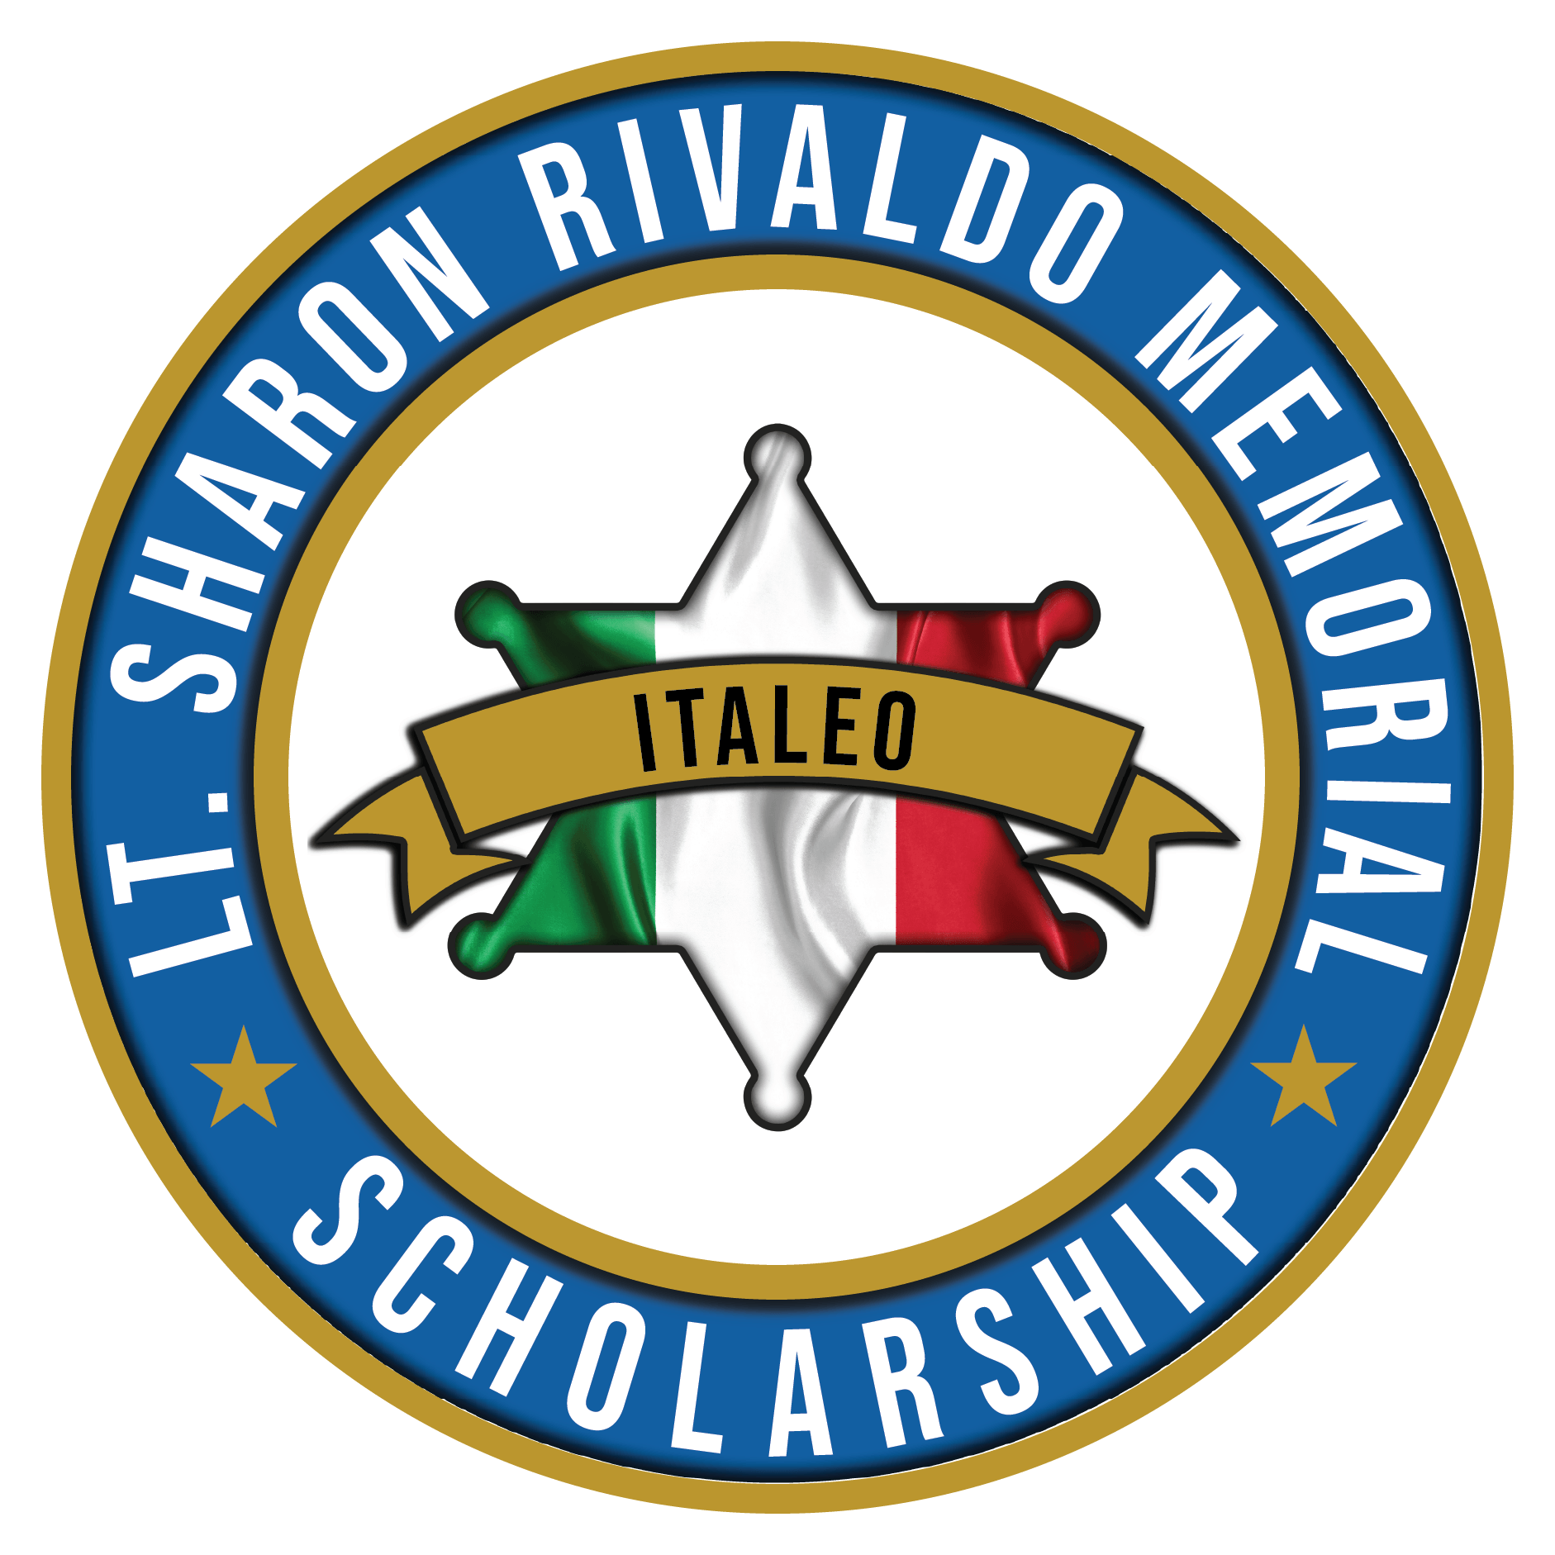
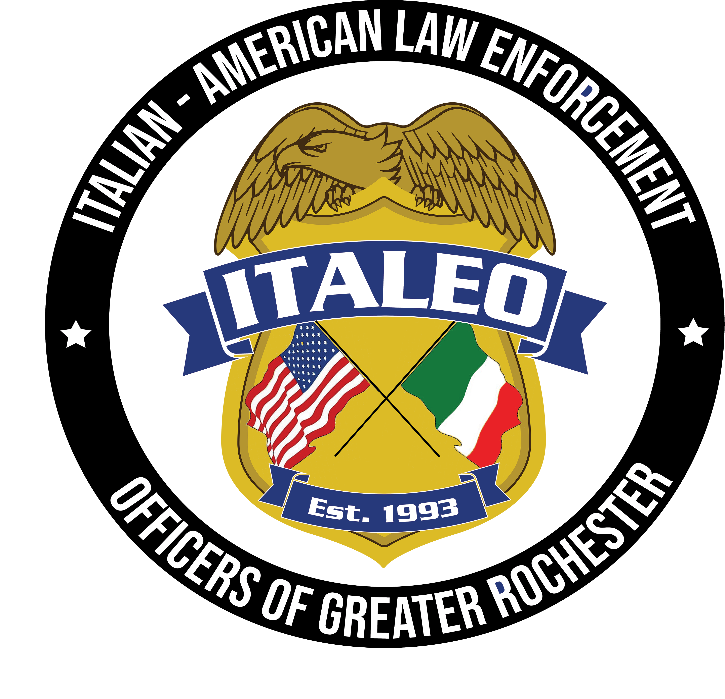

ITALIAN AMERICAN LAW ENFORCEMENT OFFICERS
OF GREATER ROCHESTER NEW YORK
SHARON RIVALDO MEMORIAL SCHOLARSHIP APPLICATION

Please complete this form in full and follow ALL instructions. There are five sections that must be completed fully in order for this application to be accepted.
1. Your Information:
Please identify your Italian lineage (check one): [ ] Mother’s Family [ ] Father’s Family [ ] Both * Please note: You must be a ITALEO member or a child, grandchild, niece or nephew of a current member in good standing.
Name:_____________________________________________________
Home Address:______________________________________________
Home City,State,Zip:_________________________________________
Home Telephone: ____________________________________________
Email Address: _____________________________________________
School Name:_______________________________________________
School Address: _____________________________________________
City,State,Zip_______________________________________________

2. College Information
Which college will you be attending next semester? __________________________________________________
Please verify your academic standing and identify your degree program.
Undergraduate Students Degree Program (B.S., B.A, Associates, etc.): ____________________________________________________
Number of undergraduate credits completed to date: _______________________________________________
Class Standing*: [ ] Freshman [ ] Sophomore [ ] Junior [ ] Senior
Cumulative GPA: ________________________ Anticipated Graduation
Date: _________________________

3. Personal Achievements
Academic Awards and Scholarships
Please list any awards or scholarships you have received: If you require more than the space provided, please continue your list on an additional sheet of paper and attach to this application.
Academic Award or Scholarship | Date Received

Clubs and Volunteer Activities

Please list service clubs or volunteer programs in which you have participated in. Include leadership positions you have held (i.e. President of Student Government) as well as those activities you have helped initiate or organize related to law enforcement interest or community service and your length of service in these endeavors:
Activity | Position Held | Dates

4. Essay
Write an essay in response to the question below.
Please limit your essay to two pages and submit it with your application.
Essay Content
Since the founding of the United States, Americans of Italian descent have contributed to the growth of our nation in all areas of human endeavor including the arts, politics, law, medicine and education, among many others.
- To what degree has your Italian American heritage, through the influence of family and friends been a motivating force behind your own personal achievements?
- Additionally, describe the Italian American ethic or cultural experiences that have shaped your thinking, attitudes and life choices.

5. Acknowledgement of rules and conditions
By submitting this information, I agree to the following:
I have read the eligibility criteria and conditions for the Sharon Rivaldo Memorial Scholarship and understand that failure to fulfill these conditions may result in forfeiture of said scholarship. I understand that the Scholarship Committee participates in the selection of the scholarship recipients, and I give my permission to release the information contained in this application to members of this committee for their consideration and accept their decisions as final.

Signature ________________________________Date______________

DEADLINE FOR APPLICATIONS IS NOVEMBER 1, 2023
Upon completing this application, sign the last page, attach your essay (and additional awards/ activities as necessary) and mail to:
ITALEO, Inc.
Attn.: Scholarship Committee
PO Box 17344
Rochester, NY 14617

or

email to: Italeorochester@gmail.com

All applications must be postmarked no later than November 1, 2023.
There will be two $500 Scholarships awarded at our annual Christmas Party. You will be notified if you have won a scholarship by November 24, 2023, and invited to attend the Christmas party on December 2, 2023 at the Italian American Sports Club on Buffalo Rd.

